INTERNAL MEMO
Date: 19th September 2018

The Chief Administrative Officer
Zombo District Local Government
P.O Box 6, Paidha

Dear Sir,
SUMMARY OF ZOMBO DISTRICT HEALTH SECTOR PERFORMANCE 2017-2018 FY

1.0 Introduction
1.1 DISTRICT PROFILE
District population | 262,121
Number of counties | 02
Number of HSD | 01
Number of sub-counties/Town councils | 13
Number of parishes | 68
Number of villages | 815

1.2 HEALTH INFRASTRUCTURE
SN | Level (II, III, IV, Hospital) | NUMBER | Ownership | Comments
1. | GENERAL HOSPITAL | 1 | PNFP
2. | HC IV | 0 | GOU | Infrastructure established to Upgrade 1 HC III to HC IV
3. | HC III | 6 | GOU
4. | HC III | 3 | PNFP | Need to takeover
5. | HC II | 9 | GOU | Two (2) operating as outreach sites
6. | HC II | 2 | PNFP | One (1) Non-functional
7. | Clinic | 2 | PFP
 | TOTAL | 23

1.3 Partnership Coordination for Health Services (Stakeholder Mapping)

Partner | Area of focus | Services offered | Where | Budget
Infectious  Diseases Institute (IDI) | HIV/AIDs | Comprehensive HIV care & Treatment. | Entire district | In kind support
AVSI | Reproductive Maternal Newborn Child & Adolescent Health Services | Strengthening Quality of Care, Infrastural Development & strengthening the referral system | 12 Health Facilities | In Kind Support & Direct Cash Transfer
Maries Stopes | Family planning | Family planning both Long Term & Short Term | Entire district | In kind support
METS/MakSPH | Monitoring and Evaluation | Monitoring and Evaluation Technical support | Entire district | In kind support
Uganda Health Supply Chain (UHSC)/Management Science for Health (MSH) | Management and health system strengthening of medicines and health commodities supplies | Medicines Supervision | Entire district | In kind support
UNICEF | Maternal & Child Health including Nutrition | Immunization, Prevention of Childhood illness, VHTs Trainings | Entire district | Direct Cash Transfer & In kind support
Partner | Area of focus | Services offered | Where | Budget
Enabel | Institutional Capacity Building | RBF Project in 6 (Six) Health facilities; Skills Development for Human Resource | Entire district | Direct Cash Transfer & In kind support
UVRI/Plague Program | Plague Control | Plague Surveillance, response & Treatment | Entire District | In kind support
UHMG/Global Fund | Malaria Control | Supply of LLINs, IEC, Trainings | Entire District | In kind support
MAPD/Malaria Consortium | Strengthened the district capacity for malaria prevention | Health workers capacity building in malaria management and reporting, Universal Net Coverage | Entire District | In kind support
Intrahealth | Enhanced capacity of the district in Management of HRH | Performance management trainings & support supervision | Entire District | In kind support
Carter Centre | Elimination of River blindness | Capacity building of health workers & Community Health Workers/VHTs, Health Education,  Mass Drug Administration, Simulium vector control | Entire District | Direct Cash Transfer & In kind support
RTI/Envision | Control of NTDs | Health education, Mass Drug Administration, Capacity building of health workers & Community Health Workers/VHTs, | Entire District | Direct Cash Transfer & In kind support

2.0 Results/Achievements FY 2017/2018
2.1 Leading Causes of morbidity in OPD FY 2017/2018
S/N | Disease conditions | # | %
1 | No Pneumonia - Cough or Cold | 62,597 | 35
2 | Malaria (Confirmed _Microscopic & RDT) | 48,570 | 27
3 | Diarrhea-Acute | 9,982 | 6
4 | Intestinal Worms | 8,140 | 5
5 | Gastro-Intestinal Disorders (non-Infective) | 7,371 | 4
6 | Pneumonia | 7,163 | 4
7 | Skin Diseases | 5,958 | 3
8 | Urinary Tract Infections (UTI) | 4,738 | 3
9 | Injuries (Trauma Due To Other Causes) | 4,200 | 2
10 | Other Eye Conditions | 3,776 | 2
 | Total | 179,855 | 100

2.2 Progress towards Health Service Delivery FY 2017/18: A focus on the core HSDP indicators …

2.2.1 Service Quality
No | Indicator | National Baseline | Target 2019/2020 | 2015/16 | 2016/17 | 2017/18 | Comments
1 | Facility based fresh still births (per 1,000 deliveries) | 16 | 11 | 15 | 10 | 7 | Performance improved, target achieved
2 | Maternal deaths reported which are audited / reviewed (%) | 33% | 65% | 40% | 0 | 67% | Performance improved, target achieved
3 | TB Treatment Success Rate (%) | 79% | 90% | 73% | 83% | 67% | Performance declined, target not achieved
4 | Patients diagnosed with malaria that are laboratory confirmed (%) | NA | 100% | 52.7% | 70.8% | 83% | Performance improved, target not achieved

2.2.2 Coverage of Interventions
No | Indicator | National Baseline | Target 2019/2020 | 2015/16 | 2016/17 | 2017/18 | Comments
5 | PCV3 Coverage (%) | 79% | 100% | 86.2% | 80.5% | 89.9% | Performance improved, target achieved
6 | ANC 4 (%) | 36.6% | 47.5% | 43.7% | 54.8% | 46.4% | Performance improved, target achieved
7 | IPT 2 (%) | NA | 93% | 50.9% | 40.9% | 65.5% | Performance improved, target achieved
8 | HIV+ women receiving ARVs for eMTCT during pregnancy & delivery (%) | 72% | 82% | 91.3% | 97.7% | 97% | Slight decline; target achieved
9 | Deliveries in facilities (%) | 52.7% | 64% | 44.2% | 46.2% | 48.6% | Performance improved, target not achieved
10 | Latrine Coverage (%) | 77% | 82% | 85% | 87% | 88% | Slight Performance improvement, target achieved

2.2.3 Health Information
No | Indicator | National Baseline | Target 2019/2020 | 2015/16 | 2016/17 | 2017/18 | Comments
11 | Timeliness of HMIS (105) reporting (%) | 88% | 97% | 99.7% | 100% | 98.5% | Target achieved
12 | Completeness of HMIS report 105 (%) | 83% | 97% | 99.7% | 100% | 100% | Target achieved

2.2.4 Management
No | Indicator | National Baseline | Target 2019/2020 | District 2015/16 | District 2016/17 | District 2017/18 | Comments
13 | Timeliness of quarterly district financial reporting (%) | NA | 60% | 50% | 0% | 0% | Not improvement

2.2.5 Sub-County League Table FY 2017/2018
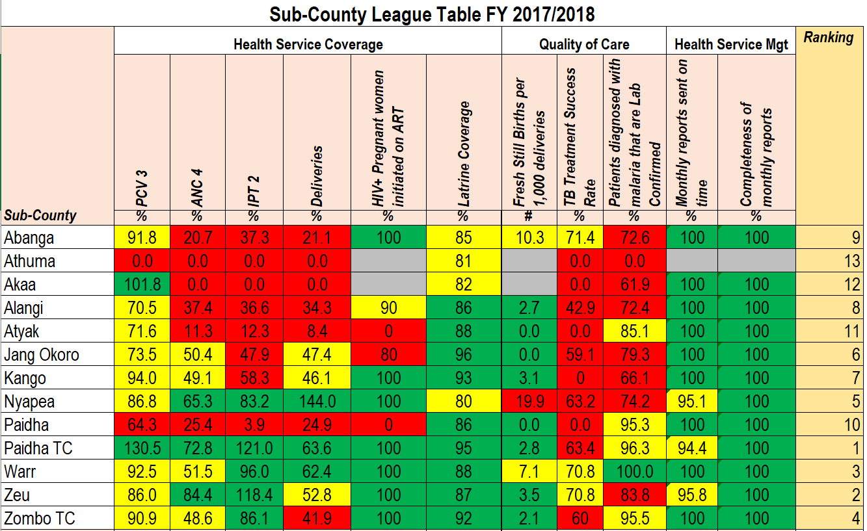

2.2.6 Development Projects FY 2017/2018
- Constructed Theatre at Warr HC III
- Refurbished Warr HC III OPD Block
- Refurbished OPD and ART Clinic in Alangi HC III
- Refurbished OPD and ART Clinic in Kango HC III
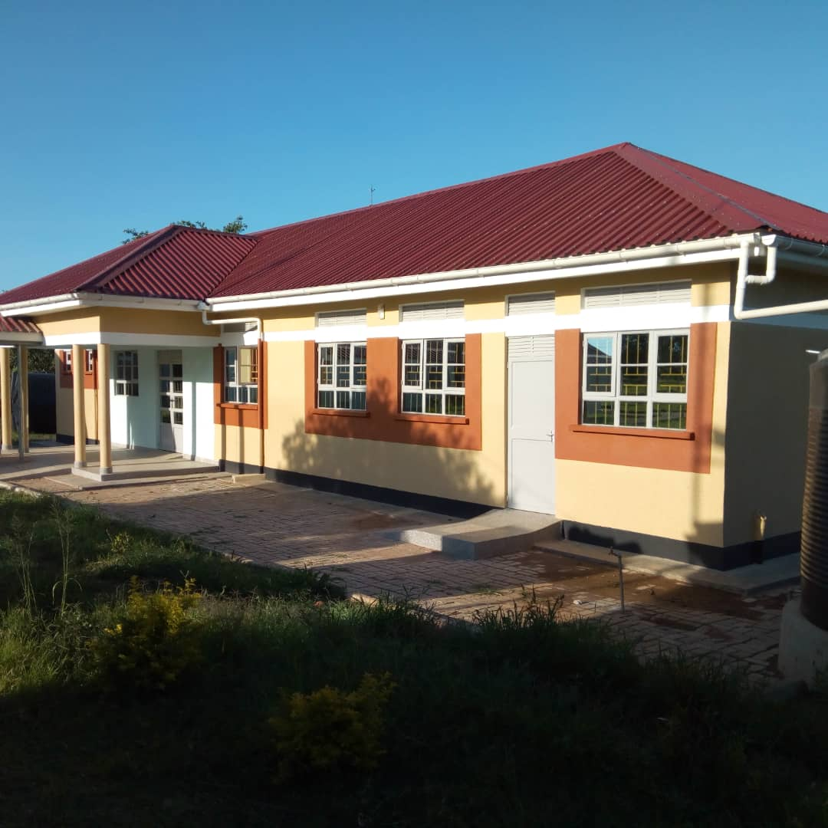
Above: Warr HC III Theatre Block

3.0 Challenges
- Absence of Key substantive DHO staffs (DHO, ADHOs, DHE & Cold Chain Tech)
- Inadequate medicines and health supplies
- Few health facilities providing Maternal services. Incl. inadequate staff houses.
- Inadequate & irregular supply of HMIS Tools
- No funding from local revenue

3.4 Lessons Learnt
- Effective engagement of stakeholder helps to smoothen implementation of health services in the District. The achievements gained are due to multi-stakeholder engagement
- Stock out of medicines and others supplies greatly negatively affects performance. TB performances were not good due to stock outs. Increased supplies from NMS is required.
- RBF implementing facilities greatly contributed positively to enhanced district performance in the quality of care indicators. Its therefore recommended that more health facilities be enrolled into RBF.
- Leadership and governance plays a key role in health service delivery. Its therefore important to have substantively appointed staffs for the health office to offer effective leadership.

3.5 Priorities for FY 2018/2019
  - Scale up ANC 4th Visit
  - Deliveries in Unit
  - Latrine Coverage
  - Maternal Death Reviews
  - TB Treatment Success Rates
  - Timeliness of PBS reports

Report compiled by:

Ongiera Sam Ajoga
Ag: District Heath Officer

